nvm installation process with error rectification

React.js download:

https://github.com/coreybutler/nvm-windows

Open window >scroll nvm windows click download now option> assets> nvm-setup.exe(5.35)>open download folder >click download file>install>skip email>next >next>finish
//After finish >open cmd>type nvm list (error means)>nvm version(error means)

Desktop-Search-Edit Environment variable(tab)-Small popup window will open
Copy the path of C:\Users\grg\AppData\Local\nvm
Open Edit Environment>Environment variable>path>new>Paste copied path>enter
System variables>path>new>paste copied path>enter

9) Create a vlog using React JS using CMS(Content Management System)
Command prompt
Open >cmd
>nvm version(1.2.2)
>nvm list( 16.20.2)
>nvm install 22.17.0
>nvm List
>node –v
>nvm use 22
Close cmd

Error means
Nvm install lts
Nvm use lts
Node -v
Npm -v

Open the Fsd workshop Folder>type cmd
>node –v
>npm create vite@latest test-react-app
>y
>select react
>select JavaScript
(optional check the fsd workshop folder there, create test-react-app folder created or not)
>cd test-react-app
>npm install
>npm run dev
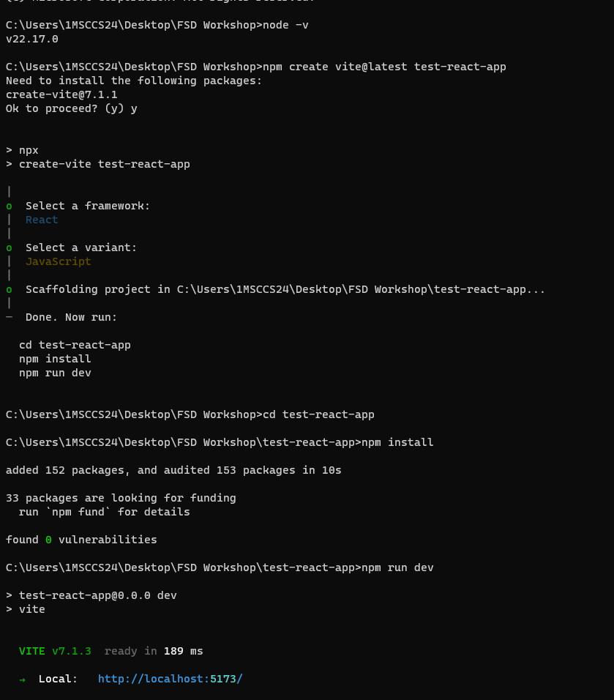

Vs code>open folder>FSD workshop Folder>test-react-app>select Folder

10) Grocery list
Command prompt
Open >cmd
>nvm version(1.2.2)
>nvm list( 16.20.2)
>nvm install 22.17.0
>nvm List
>node –v
>nvm use 22
Close cmd

Open the Fsd workshop Folder>type cmd
>node –v
>npm create vite@latest grocery-app
>y
>select react
>select JavaScript
(optional check the FSD workshop folder, there create grocery-app can folder created or not)
>cd grocery-app
>npm install
>npm install react-router-dom
>npm install bootstrap
>npm run dev


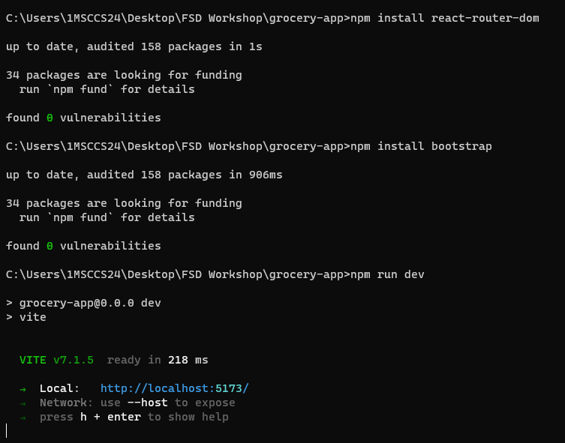

VS Code>open folder>FSD workshop Folder>grocery-app>select folder

9) Create a vlog using React JS using CMS(Content Management System)
Aim:
To develop a user-friendly and scalable vlog platform using React JS for the front-end and a CMS (Content Management System) for managing video content.
Algorithm:
Step 1: Start the program
Step 2: Initialize the React project using Create React App or Vite for fast setup.
Step 3: Choose and configure a CMS like Strapi or Contentful to manage video content.
Step 4: Create data models in the CMS for videos with fields like title, description, and video URL.
Step 5: Fetch video data from the CMS API using fetch or axios in the React app.
Step 6: Display video thumbnails and details in a list component for users to browse.
Step 7: Implement video playback using the HTML5 <video> tag or the react-player library.
Step 8: Add user interactions such as searching, filtering, and viewing video details.
Step 9: Create an admin panel for authenticated users to add, edit, or delete video entries.
Step 10: Style the UI using CSS frameworks like Bootstrap or Tailwind for a modern look.
Step 11: Deploy the app to hosting services and ensure proper authentication, scalability, and performance.
Step 12: Stop the program.

Coding:
App.jsx
import { useState } from 'react'
import reactLogo from './assets/react.svg'
import viteLogo from '/vite.svg'
import './App.css'
import MyHome from './components/MyHome'
function App() {
const [count, setCount] = useState(0)
return (
<> <MyHome/></>
)
}
export default App
MyHome.jsx()
import React,{useState} from "react";
function MyHome(){
const handleClick=()=>{
alert(`You clicked button`);
};
return (
<div>
<h1>My Home Component</h1>
<p>This is a simple home component.</p>
<button onClick={handleClick}>Submit</button></div>
);
}
export default MyHome;
Output:
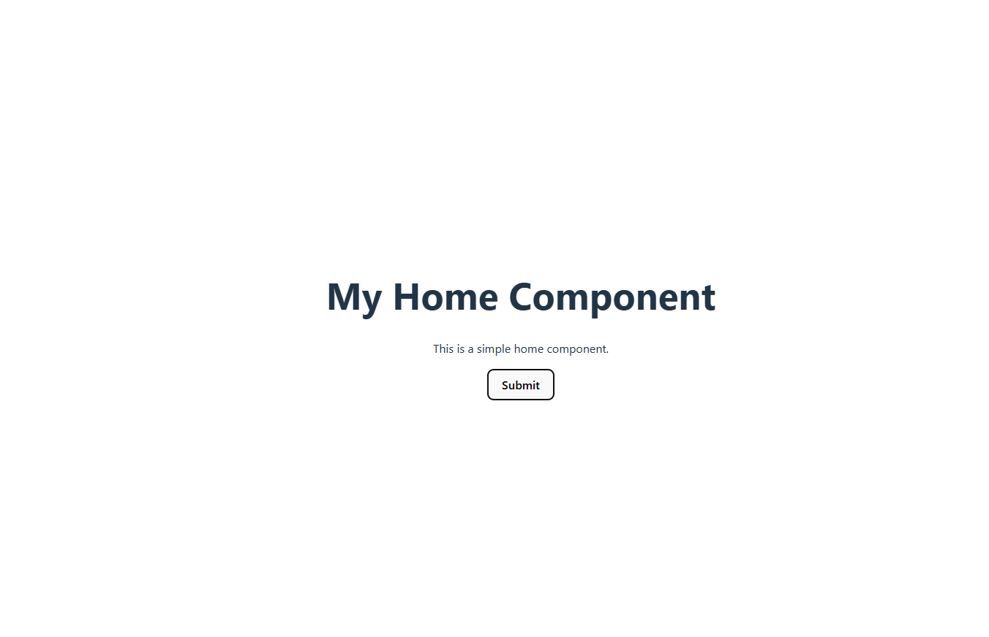

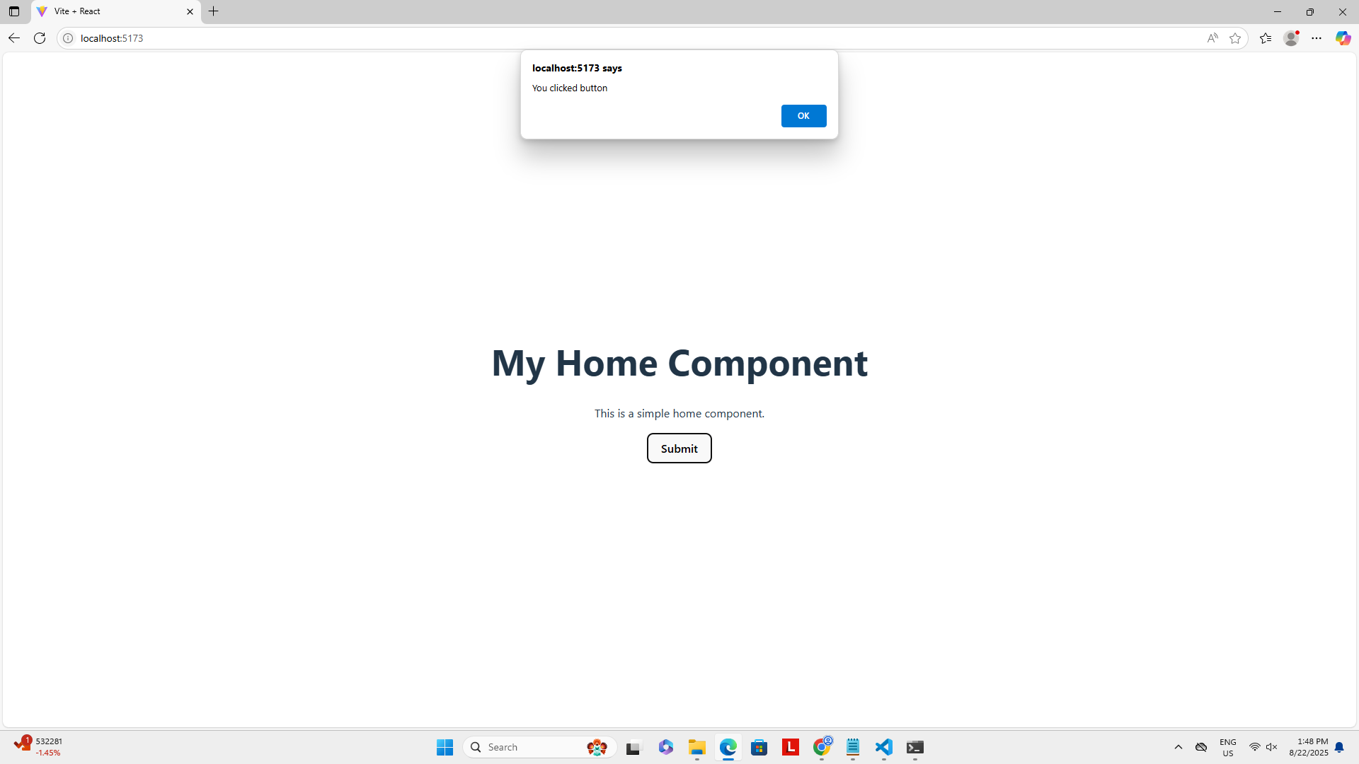

10) Create a project on a grocery list, delivery application

Aim:
To create a simple and interactive grocery shopping application using React. It allows users to browse grocery items, add them to a cart, remove items, and persist the cart data across sessions, along with providing admin login functionality.

Algorithm:
Step 1: Start the application and initialize the state for cart and user inputs.
Step 2: Display grocery items with their images, names, and prices on the homepage.
Step 3: Allow the user to add items to the cart by clicking “Add to Cart”.
Step 4: Store the cart data in localStorage to persist it across sessions.
Step 5: Provide an admin login page that verifies credentials (username and password).
Step 6: Navigate to the cart page when the login is successful.
Step 7: Show all items in the cart, retrieved from localStorage.
Step 8: Allow users to remove items from the cart, updating localStorage.
Step 9: Handle user interactions like clicking buttons and submitting forms using event handlers.
Step 10: End the application flow by continuously updating the UI based on user actions

Coding:
App.jsx

import { useState } from 'react'
import './App.css'

import 'bootstrap/dist/css/bootstrap.min.css'
import 'bootstrap/dist/js/bootstrap.min.js'
import RouterFile from './components/RouterFile'
import Home from './components/Home'

function App() {

return (
<>
<RouterFile/>
</>
)
}

export default App

Main.jsx

import { StrictMode } from 'react'
import { createRoot } from 'react-dom/client'
// import './index.css'
import App from './App.jsx'
import { BrowserRouter } from 'react-router-dom'

createRoot(document.getElementById('root')).render(
<StrictMode>
<BrowserRouter>
<App />
</BrowserRouter>
</StrictMode>,
)

AdminLogin.jsx()
import React, { useState } from 'react';
import { useNavigate } from 'react-router-dom';

const AdminLogin = () => {
const [username, setusername] = useState('');
const [password, setPassword] = useState('');
const navigate=useNavigate()

const handleLogin = (e) => {
e.preventDefault();
console.log('Login submitted');
console.log('username:', username);
console.log('Password:', password);
if (username === 'admin' && password === 'admin') {
alert('Login successful');
navigate("/cart")
} else {
alert('Invalid username or password');
}
// You can add actual login logic here
};

return (
<div className="container mt-5" style={{ maxWidth: '400px' }}>
<h2 className="text-center mb-4">Login</h2>
<form onSubmit={handleLogin}>
<div className="mb-3">
<label htmlFor="email" className="form-label">
username
</label>
<input
type="text"
className="form-control"
id="email"
placeholder="Enter username"
value={username}
onChange={(e) => setusername(e.target.value)}
required
/>
</div>

<div className="mb-3">
<label htmlFor="password" className="form-label">
Password
</label>
<input
type="password"
className="form-control"
id="password"
placeholder="Password"
value={password}
onChange={(e) => setPassword(e.target.value)}
required
/>
</div>

<button type="submit" className="btn btn-primary w-100">
Login
</button>
</form>
</div>
);
};

export default AdminLogin;

Cart.jsx

import { use } from "react";
import { useState,useEffect } from "react";

const CartView = () => {
const [cart,setCart]=useState([])
useEffect(()=>{
const cartData=JSON.parse(localStorage.getItem("cart"))||[]
setCart(cartData)

},[])
const removeFromCart=(itemId)=>{
const updateCart=cart.filter((item)=>item.id!== itemId)
setCart(updateCart)
localStorage.setItem("cart",JSON.stringify(updateCart))
}
return (
<div>
<h2>Cart Items</h2>
{cart.length === 0 ? (
<p>No items in cart.</p>
) : (
<ul>
<div className="row">
{cart.map((item) => (
<div className="col-md-3 mb-2">
<div className="card">
<div className="card-body text-center">
<img src={item.image} className="card-img-top" alt="#" width="200px" height="200px" />
<h5 className="card-title">{item.name}</h5>
<p className="card-text">Price: ${item.price}</p>
<button className="btn btn-danger" type='button' onClick={(e) => {
e.preventDefault();
removeFromCart(item.id)
}}>
remove
</button>
</div>
</div>
</div>
))}
</div>
</ul>
)}
</div>
);
};

export default CartView

Global.js
export const cart=[]

Home.jsx

import apple from '../assets/images/apple.jpg'
import banana from '../assets/images/banana.jpg'
import bread from '../assets/images/bread.jpg'
import milk from '../assets/images/milk.jpg'
import eggs from '../assets/images/eggs.jpg'
import pasta from '../assets/images/pasta.jpg'
import { useNavigate } from 'react-router'
const Home = () => {
const groceryItems = [
{ id: 1, name: 'Apples', price: 2.5 , image:apple},
{ id: 2, name: 'Bananas', price: 1.2 , image:banana},
{ id: 3, name: 'Bread', price: 3.0 , image:bread},
{ id: 4, name: 'Milk', price: 2.0 , image:milk},
{ id: 5, name: 'Eggs', price: 2.8 , image:eggs},
{ id:6, name: 'Pasta', price: 4.5 , image:pasta},
];

const addToCart = (item) => {
const existingCart=JSON.parse(localStorage.getItem("cart"))||[]
const updateCart=[...existingCart,item]
localStorage.setItem("cart",JSON.stringify(updateCart))
console.log("item added",updateCart)
alert("Cart added")

};

const navigate = useNavigate()
// const adminlogin=()=>{
// navigate("/admin")
// }
return (
<div className="container">
<center><h1>Grocery Shop</h1></center><div className='text-end'><button className='btn btn-success' onClick={()=>{navigate("/admin")}} type='button'>admin</button></div><br />
<ul>
<div className="row">
{groceryItems.map((item) => (
<div className="col-md-4 mb-2">
<div className="card">
<div className="card-body text-center">
<img src={item.image} className="card-img-top" alt="#" width="200px" height="200px" />
<h5 className="card-title">{item.name}</h5>
<p className="card-text">Price: ${item.price}</p>
<button className="btn btn-primary" type='button' onClick={(e) => {
e.preventDefault();
addToCart(item)
}}>
Add to Cart
</button>
</div>
</div>
</div>
))}
</div>
</ul>
</div>
);
};

export default Home;

RouterFile.jsx

import React from 'react'
import { Routes, Route } from 'react-router-dom';
import AdminLogin from './AdminLogin';
import Home from './Home';
// import Cart from './Cart';
import CartView from './Cart';
const RouterFile = () => {
return <div>
<Routes>
<Route path="/" element={<Home />} />
<Route path="/admin" element={<AdminLogin />} />
<Route path="/cart" element={<CartView />} />
</Routes>
</div>
}
export default RouterFile

Output:

